Lane Snively

Quinton Hetland

Senior Design 1

December 9, 2022

**Media Creation by Conversion**

**Overview / Executive Summary**

We will create an Android application that creates media by converting one file type to another using algorithms that can be altered in a settings menu.

Popular tools that create media rely on machine learning models that are invisible to the user. This means that users cannot see how the media was created and outcomes of media creation may vary based on the same input. We want to explore an alternative method for media creation that relies on a set of simple user defined conversion algorithms that will consistently produce the same result using the same settings. This will be accomplished using pure functions that create no side effects. Our algorithms will be able to convert file A to file B and back to A using the same conversion algorithms in either direction.

The completed project will resemble a computerized implementation of the following image:

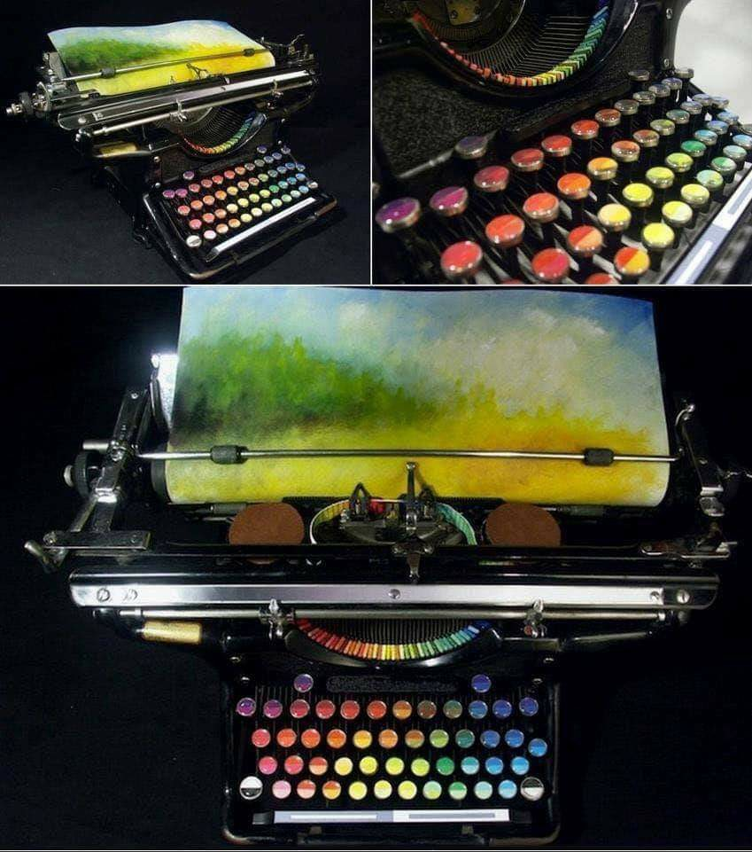

**The Team**

Lane Snively

* Role: Lead Programmer, co-designer
* Biography: A skateboarder that loves abstraction. A Computer Science major with a minor in Mathematics.

Quinton Hetland

* Role: Lead Designer, co-programmer
* Biography: A guy that likes functional programming and the math behind it. A Computer Science major with a minor in Statistics and an emphasis on Big Data.

**Minimum Viable Product**

GENERAL APP DESIGN

* Appearance:
  + App icon that Data Doppelganger designs
  + Dark mode, no light mode option
  + Extreme ease of use

FRONT-END

MAIN PAGE

* Data Doppelganger logo with buttons surrounding it
* Buttons
  + Tutorial that explains uses of the app
  + User created example results
  + File input
  + Conversion settings menu
  + Execute conversion

DISPLAY AND EDITING OF RESULTS PAGE

* Display result after conversion of media file type: text, image, video, sound
* Buttons
  + Reset to original file
  + Undo previous action
  + Apply previous action again
  + Apply default conversion to result
  + Save result

BACK-END

CONVERSION SETTINGS MENU

* Change algorithm for converting from / to the following media file type
  + Text
    - Character / word / sentence / file length
    - Character / word frequency
    - Capital letter frequency
    - Vowel frequency
    - Page / paragraph number
    - Relevant words
  + Image
    - Pixel / row / column count
    - Pixel / row / column color frequency
    - Pixel color

**High Level Systems Overview**

The following is the expected user interaction with the tool.

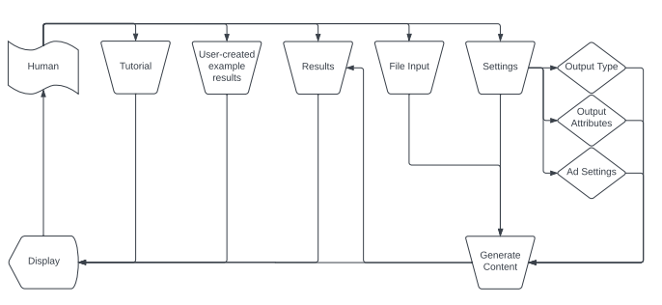

The following is the expected system interaction.

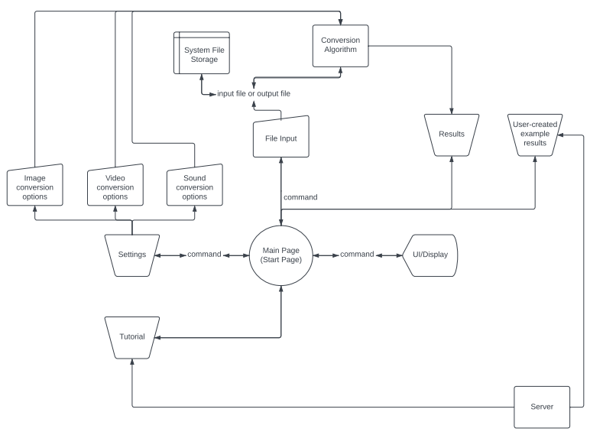

System Creation

We will use Java to create the app in Android Studio.

System

The MAIN PAGE will consist of the first fragment.

The RESULT / EDITING PAGE will consist of the second fragment.

Each setting will be toggled by one Java class that contains conversion algorithms.

Components

Display capabilities for all supported file types

Algorithms for changing a media file and returning the resulting media file

File saving capabilities

Expected User Interactions

Input a media file

Change settings

Convert file

View file

Edit file

Save file

**Major Milestones**

Front-End of Application Runs - A working app that doesn’t crash and can be given a file (no translations yet).

* Reached once we get it running and working for all initial components.

Translate Text & Image - Application can translate between text based file types and image file types.

* Reached once our app can take an image or text file as input and output / save the translated version.

**Tasks**

During Winter Break

* Create settings menu application
* Create file management application
* Combine applications for a complete front-end application

During February 2023

* Implement conversion algorithms for a complete minimum viable product

During March 2023

* Expand conversion algorithms for additional file types
  + Text
  + Image
  + Audio
  + Video

During April 2023

* Publish app to Google Play store
* Configure updates